

Closing press release
(English translation)

TTG TRAVEL EXPERIENCE AND INOUT:
AMAZING TURNOUT, UP 9% ON PREVIOUS EDITION

- All the goals of the 61st edition of the largest tourism marketplace were met, with a bonus of a +15% increase in foreign attendance
- Attending the trade fair 2,700 exhibiting brands, 1,000 foreign buyers from 75 countries and 66 foreign destinations, 18 thousand business meetings on the matching platform, 683 journalists
- The leitmotif of 2024, "Veritas", unfolded by 250 speakers in the 200 appointments including talks, seminars and conferences in the 9 Arenas

ttgexpo.it | inoutexpo.it

Rimini, 11 October 2024 – A record number of qualified attendees (+ 9% total and + 15% foreign attendance, compared to 2023) for the 61st edition of TTG Travel Experience and the second Inout | The Contract Community, organised by Italian Exhibition Group (IEG) which concluded successfully today at Rimini Expo Centre. A surge in numbers that confirms the excitement of the tourism industry, which placed the fair at the centre of attention of institutions, international buyers, industry companies, and the media. The most important b2b event at a national level for the tourism industry brought 2,700 exhibiting brands, 1,000 buyers from all over the world, 55 start-ups, and 683 Italian and foreign journalists to Rimini. There was also a record number of 18,000 business meetings over the three days.

TURISMO, A NEW NEED FOR TRUTH IS BORN
VERITAS, the main theme of TTG, unfolded over the 200 events with 250 speakers in the 9 arenas, declining the concept in all its different facets through talks and debates. The search for truth for tourism has focused on the need to rely on truthful stories about the destinations, real trend data and scientifically verifiable market analyses in a time in which storytelling is artificially created, fake news is rampant, and reviews are often misleading.

TTG TRAVEL EXPERIENCE, A THOUSAND BUYERS FROM ALL OVER THE WORLD AND 66 FOREIGN DESTINATIONS. ITALY IMPACTS WITH ALL ITS 20 REGIONS
Villages, art cities, food and wine, not to mention the growth of cycling tourism, have made Italy the most popular destination, and are just a part of the offer that attracted the thousand foreign buyers present at the fair from 62 countries (55% from Europe and 45% from the rest of the world), led by North America (18%), followed by the UK (15%) and Germany (10%). TTG is making its mark as an increasingly international fair, welcoming 66 foreign destinations, from Europe to Asia, from the Middle East to Africa, and the Americas. TTG also brought all 20 Italian regions to Rimini, making the fair a convergence of excellence for incoming tourism.

A BOOM IN LUXURY TOURISM IN ITALY
Italy is also leader in the European luxury hotel market, with an annual turnover of 30.5 billion euros and a market share of 21%. In our country, 45% of hotel investments are focused on the luxury segment and concentrated on top cities (Rome, Milan, Venice and Florence), as well as on seaside and mountain areas (Source: Deloitte). TTG has intercepted this trend by creating a specific event: the Luxury Event by TTG. A format with the active engagement of buyers involved in 1,400 appointments, confirming the expertise of the Italian luxury players, focused on the needs of the new high-end tourist in search of extraordinary experiences.

TTG NEXT START-UP
TTG 2024 has created an authentic Tourism Innovation District with 55 start-ups all set to revolutionise the industry in the areas of Technology, Mobility, Hospitality, Experience and Tour Operating. The programme included 20 conferences and round tables, as well as the Startup Pitching Session, which awarded the best emerging startups in Tourism.

SANTANCHÈ: “TOURISM IS A FUNDAMENTAL PILLAR FOR THE ECONOMIC AND CULTURAL GROWTH OF OUR NATION”
The trade associations representing the various sectors of the tourism and hospitality industry, as well as the academic world with universities and cultural institutions, were all in attendance at TTG and InOut. At the inauguration, the Minister of Tourism, Daniela Santanchè underlined the essential role of tourism as a fundamental pillar for the growth of the nation and that of TTG as a reference event in Italy for the worldwide promotion of the industry. Also present were Maurizio Ermeti, president of IEG, Jamil Sadegholvaad, mayor of Rimini, Andrea Corsini, councillor for Tourism of Emilia-Romagna, Pier Ezhaya, president of ASTOI-Confindustria Viaggi, Franco Gattinoni, president of FTO-Federazione Turismo Organizzato, Flavio Ghiringhelli, president of IBAR-Italian Board Airline Representatives, Bernabò Bocca, president of Federalberghi, Federico Pedini Amati, Secretary of State for Tourism of the Republic of San Marino and Gian Marco Centinaio, vice president of the Senate of the Republic.

INOUT: THE SECOND EDITION OF THE FORMAT DEDICATED TO THE CONTRACT MARKET
A successful second year for Inout | The Contract Community, the format dedicated to indoor and outdoor furnishings for hotel and non-hotel hospitality. New trends, cutting-edge technologies and new solutions for the industry were unveiled, from hotel room design to greenery planning, from the choice of materials and surfaces to the design of beach resorts.

Till next time… Italian Exhibition Group looks forward to seeing all the players of the Italian and international tourism industry at the next edition in Rimini Expo Centre from 8-10 October 2025.

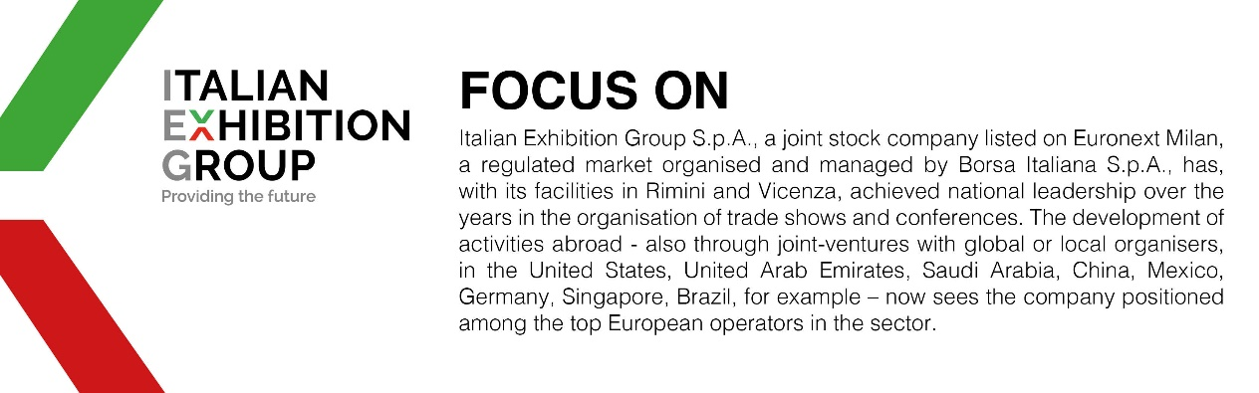

This press release contains forecast elements and estimates that reflect the management’s current opinions (“forward-looking statements”), particularly regarding future management performance, realization of investments, cash flow trends and the evolution of the financial structure. For their very nature, forward-looking statements have a component of risk and uncertainty, as they depend on the occurrence of future events. The effective results may differ (even significantly) from those announced, due to numerous factors, including, only by way of example: food service market and tourist flow trends in Italy, gold and jewellery market trends, green economy market trends; the evolution of raw material prices; general macroeconomic conditions; geopolitical factors and evolutions in the legislative framework. Moreover, the information contained in this release does not claim to be complete, and has not been verified by independent third parties. Forecasts, estimates and objectives contained herein are based on the information available to the Company as at the date of this release.

